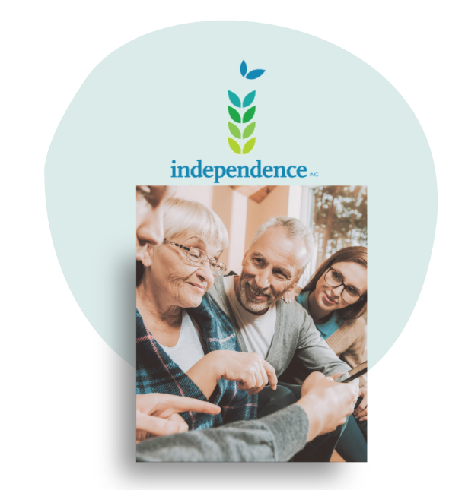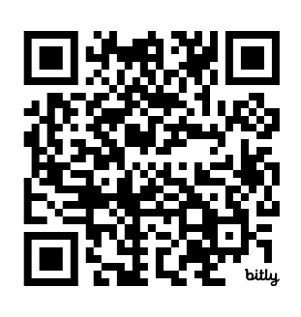
Independence, Inc.
Kansas City, KS office
serving Wyandotte and Johnson counties
913-354-6882

Scan this QR Code to go directly to our Kansas City, Kansas Core Services Page

Independence, Inc. is now serving Johnson and Wyandotte counties with all our Core Services including:
Information & Referral: Do you need information on agency or community resources? Contact our Information and Referral Specialist and we will respond during business hours: greynolds@independenceinc.org or 913-354-6882 ext. 110
Advocacy: Individual advocacy involves working with people with disabilities to help develop the skills necessary to represent themselves in all kinds of situations, helping them to act on their own behalf to settle disputes, obtain housing or employment, ask for accommodations, or obtain support services from community agencies.
Independent Living Skills Training: The goal of the Independent Living Skills Program of Independence, Inc. is to assist individuals with disabilities in maximizing their potential to lead fulfilling and productive lives in their homes and the community, through practical and hands-on training in basic life skills like money management, budgeting, healthy cooking, using technology, cleaning, understanding public transit systems and schedules and much more.
Peer Support and Peer Counseling: Individuals with disabilities who have gained knowledge and skills in independent living, assist others in coping with their disability-related experiences. We do this through both a one-on-one Peer Counseling relationship with trained volunteers, and through our consumer-led Peer Groups, organized and facilitated by a staff member.
Nursing Home Transition Services: Nursing Home Transition (or Deinstitutionalization) is a core service that reflects our values and belief that placement of people with disabilities in institutions or nursing homes is inappropriate. Independence, Inc. provides services to assist a person with a disability make the transition from a nursing home or institution to a home of their choosing in the community.
Contact:

LaNeece Jardon, Core Services Manager, Johnson and Wyandotte counties
ljardon@independenceinc.org 913-354-6882 ext. 108
Sara Comstock, Community Integration Coordinator, Johnson and Wyandotte counties
scomtock@independenceinc.org 913-354-6882 ext. 115
Visit our Kansas City office Core Services page: https://independenceinc.org

